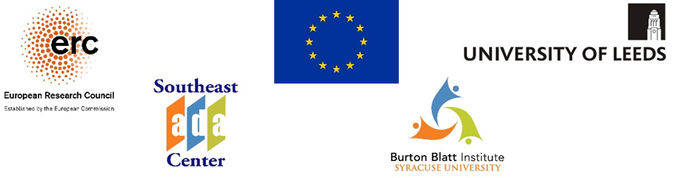
We Want Your Story
for the
Inclusive Public Space Research Project
Web: InclusivePublicSpace.leeds.ac.uk

About the Inclusive Public Space Research Project
This research project investigates problems caused by unequal access to streets in ten cities around the world. One of the cities that we have chosen is Syracuse, New York. We want to:
- review the ways that street access is covered by laws in cities and countries around the world;
- learn how the government responds to the problems of unequal access;
- understand your personal experiences with inaccessible streets in the city of Syracuse;
- learn about the reasons you have or have not reported street accessibility problems; and
- talk with you about your thoughts on good practices and how to improve accessibility.
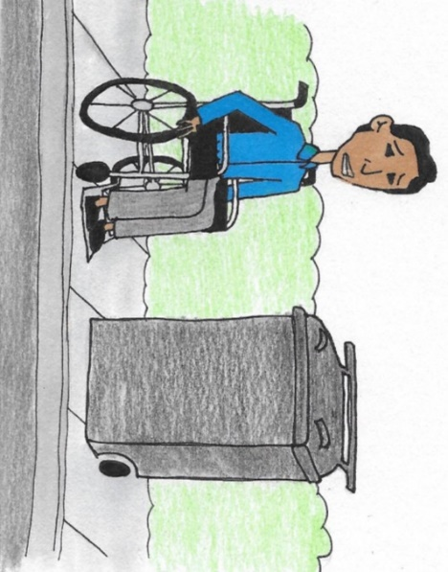

What might limit access?
- Physical distancing measures
- Electric scooters, bikes, silent cars
- Floating bus-stops
- Confusing or dangerous crosswalks
- Blockages and low branches
- Slip and trip hazards
- Spaces that have to be shared with vehicles
- Pedestrians who look at their phones
- Poor signage, lighting, noise, fumes
- Road construction
- And, so much more!

Who Do We Want To Interview?
We want to talk with any pedestrians who find streets difficult to use, particularly people with disabilities, older adults, parents, or caregivers. We can set up an interview by phone or online. You may contact us by:
- Email: IPS.project@leeds.ac.uk
- Phone (Voice/Relay/Text): (678) 701-3771 or (315) 314-4179
- Online Form: Inclusive Public Space Project - Expression of Interest for Interview (web: leeds.onlinesurveys.ac.uk/expression-of-interest_usa)
- Website: Inclusive Public Space Research Project
(web: InclusivePublicSpace.leeds.ac.uk)
- U.S. Mail:
IPS Project
950 Irving Avenue Dineen Hall, Suite 446
Syracuse, NY 13244-213

Other Ways to Get Involved
As we progress with our research, there will be other opportunities to get involved. We want to share guides, tools, and resources with people who are interested in making city streets more accessible. Your voice is important! We want to learn from you.

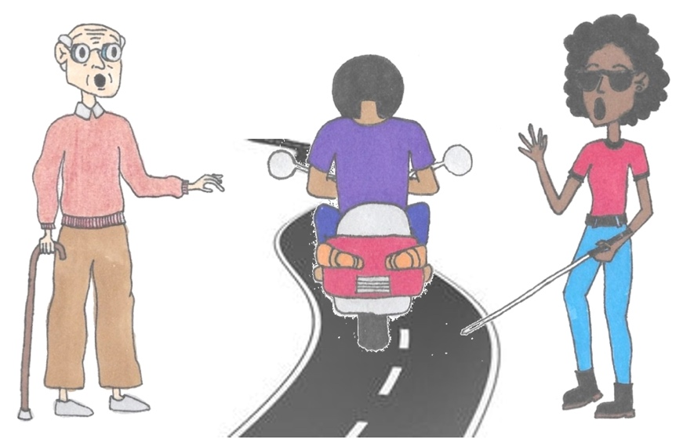

The drawings are courtesy of Louise McCann. This project has received funding from the European Research Council (ERC) under the European Union’s Horizon 2020 research and innovation programme (Grant agreement no. 787258).

